

SCHOOL OF Business

**GROUP ASSIGNMENT COVER SHEET**

|  |  |  |  |  |  |  |  |  |  |  |  |  |  |  |  |  |  |
| --- | --- | --- | --- | --- | --- | --- | --- | --- | --- | --- | --- | --- | --- | --- | --- | --- | --- |
| **STUDENT DETAILS** | | | | | | | | | | | | | | | | | |
| Student name: | | | | Maedeh (Mia) Dehghan | | | | | | Student ID number: | | | | 22173370 | | | |
| Student name: | | | | Anupama Poudel | | | | | | Student ID number: | | | | 22214180 | | | |
| Student name: | | | | Zarrar khan | | | | | | Student ID number: | | | | 22168452 | | | |
| Student name: | | | | Israt Jahan Joty | | | | | | Student ID number: | | | | 22166664 | | | |
| Student name: | | | | Andrew Mark Parimalasingham | | | | | | Student ID number: | | | | 22215364 | | | |
|  | | | | | | | | | | | | | | | | | |
| **UNIT AND TUTORIAL DETAILS** | | | | | | | | | | | | | | | | | |
| Unit name: | | | Business Analytics in Practice | | | | | | | | | Unit number: | | | BUSM 7105 | | |
| Tutorial/Lecture: | | | | | Group1 | | | | | | Class day and time: | | | | | Monday 6-9 p.m | |
| Lecturer or Tutor name: | | | | | | | Dr. Abdul Babar | | | | | | | | | | |
|  | | | | | | | | | | | | | | | | | |
| **ASSIGNMENT DETAILS** | | | | | | | | | | | | | | | | | |
| Title: | | Applied Project | | | | | | | | | | | | | | | |
| Length: | | 1500 words | | | | | Due date: | 15/08/2025 | | | | | Date submitted: | | | | 15/08/2025 |
| Home campus (where you are enrolled): | | | | | | | | | 169 Peter Shergold Building, Parramatta City Campus | | | | | | | | |
|  | | | | | | | | |  | | | | | | | | |
| **DECLARATION** | | | | | | | | | | | | | | | | | |
|  | I hold a copy of this assignment if the original is lost or damaged. | | | | | | | | | | | | | | | | |
|  | I hereby certify that no part of this assignment or product has been copied from any other student’s work or from any other source except where due acknowledgement is made in the assignment. | | | | | | | | | | | | | | | | |
|  | I hereby certify that no part of this assignment or product has been submitted by me in another (previous or current) assessment, except where appropriately referenced, and with prior permission from the Lecturer / Tutor / Unit Coordinator for this unit. | | | | | | | | | | | | | | | | |
|  | No part of the assignment/product has been written/produced for me by any other person except where collaboration has been authorised by the Lecturer / Tutor /Unit Coordinator concerned. | | | | | | | | | | | | | | | | |
|  | I am aware that this work will be reproduced and submitted to plagiarism detection software programs for the purpose of detecting possible plagiarism **(which may retain a copy on its database for future plagiarism checking).** | | | | | | | | | | | | | | | | |
| **Student’s signature:** | | | | | | Maedeh (Mia) Dehghan | | | | | | | | | | | |
| **Student’s signature:** | | | | | | Anupama Poudel | | | | | | | | | | | |
| **Student’s signature:** | | | | | | Zarrar khan | | | | | | | | | | | |
| **Student’s signature:** | | | | | | Israt Jahan Joty | | | | | | | | | | | |
| **Student’s signature:** | | | | | | Andrew Mark Parimalasingham | | | | | | | | | | | |
| **Note:** An examiner or lecturer / tutor has the right to not mark this assignment if the above declaration has not been signed. | | | | | | | | | | | | | | | | | |

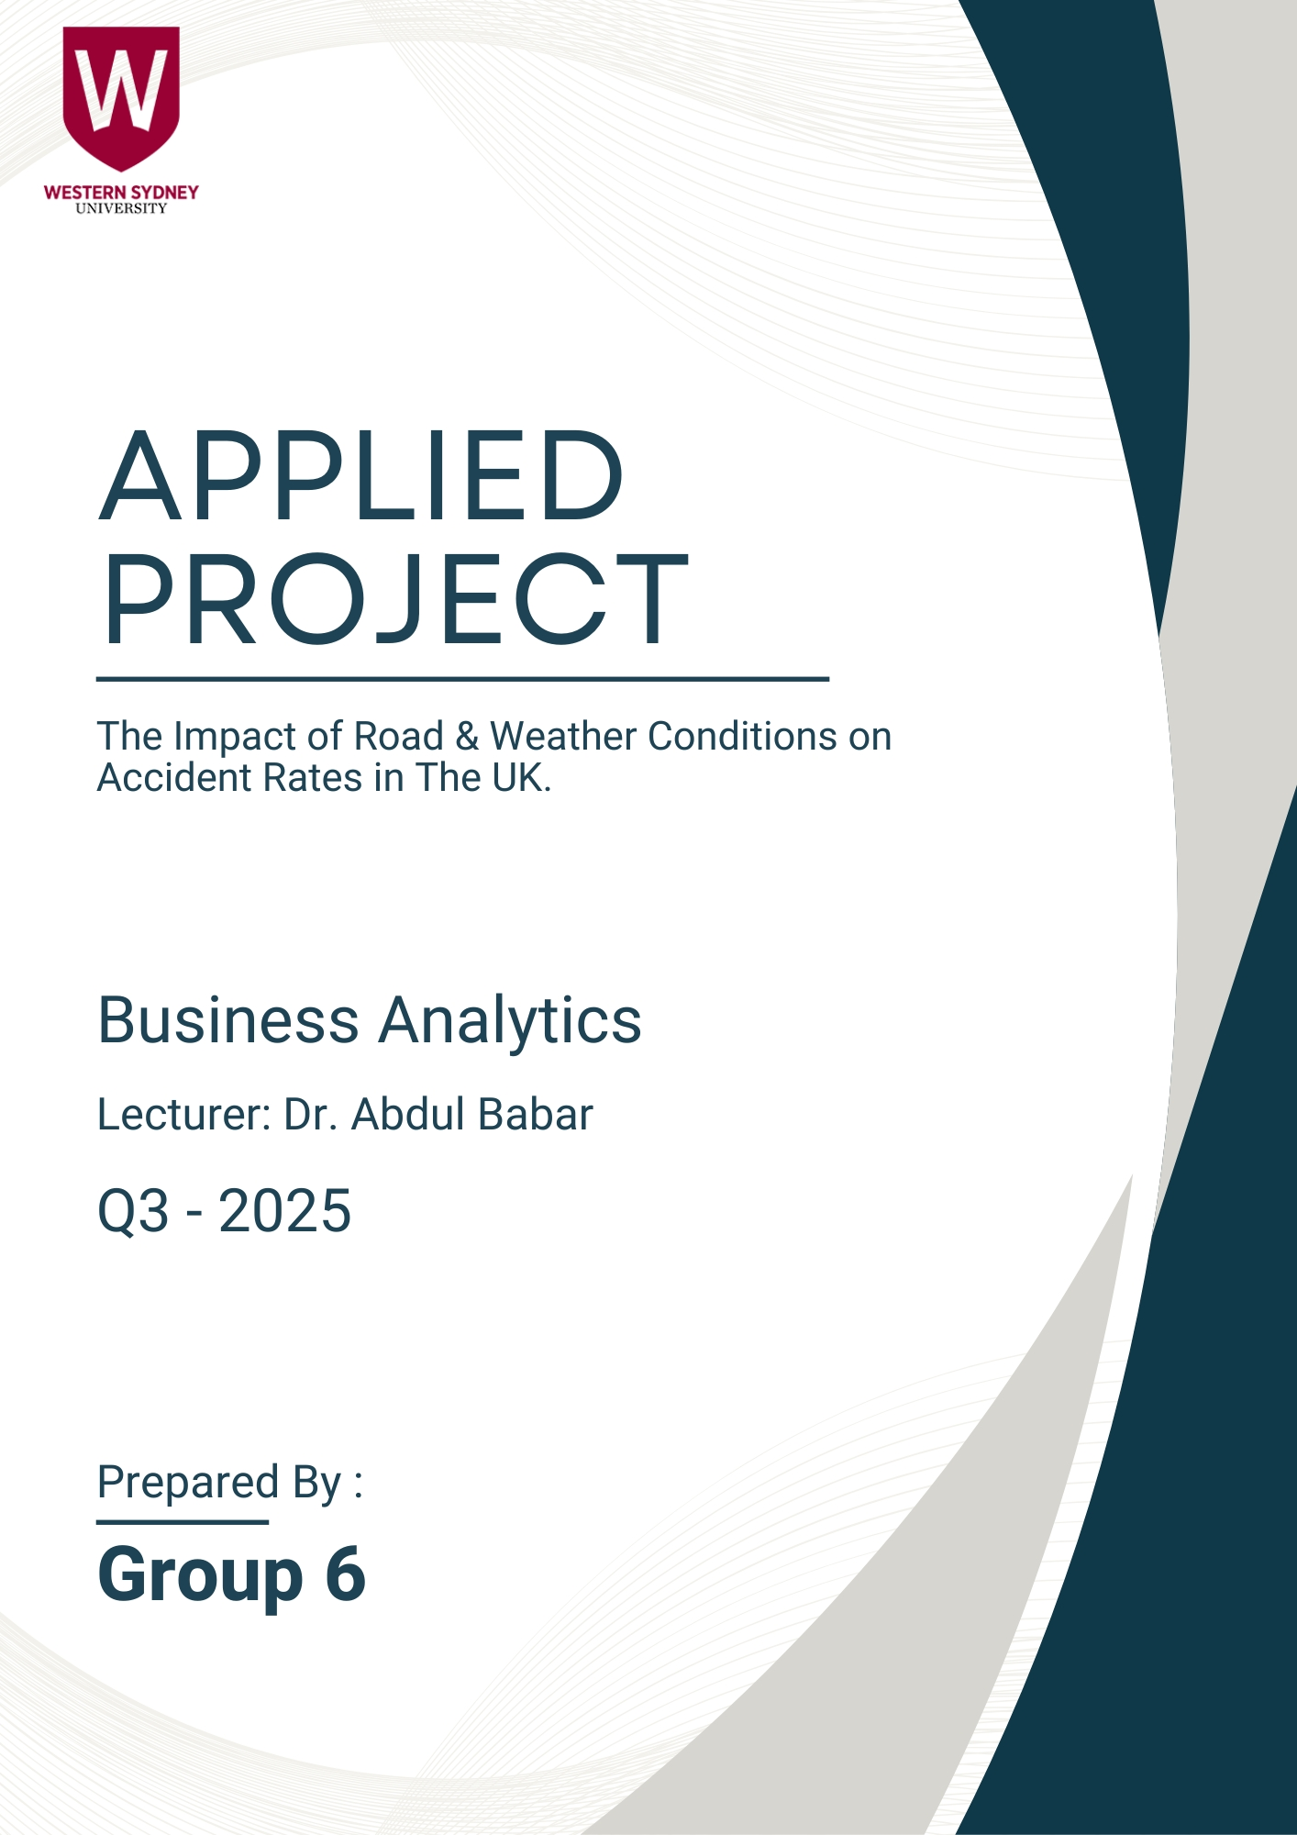

Table of Content

1. Executive Summary 6

2. Introduction 6

3. Scope of the Project 7

4. Problem Statement 8

5. Research Questions 9

6. Key Stakeholder Analysis 9

7. Project Deliverables 10

8. Data Description 11

9. Reporting Visuals 12

10. Decision-making Process for Solution Selection 15

11. Conclusion 16

12. References 17

Contribution Log 19

Table of Figures

Figure 1- Project Scope 7

Figure 2- The Strengths & Limitations of the Dataset 11

Figure 3- Overall Accident Trends 12

Figure 4- Weather Conditions vs. Accident Severity 12

Figure 5- Road Surface vs. Accident Severity 13

Figure 6- The Correlation Between Road & Weather Conditions 13

Figure 7- Road Type vs. Number of Accidents 14

Figure 8- Light Conditions vs. Number of Accidents 14

Figure 9- The Correlation Between Road Types & Light Conditions 14

# Executive Summary

This report presents an in-depth analysis of the causes of rood traffic accidents in the UK, by means of data analytics and visualizations to uncover patterns from a raw dataset to actionable insights for the decision-making process. The report focuses on key dimensions such as accident severity, weather and road conditions, high-risk locations, light conditions and visibility to other temporal trends.

The analysis is done to support evidence-based decision making, aimed at reducing the causalities occurring and to inform relevant stakeholders such as transportation authorities, law enforcement agencies, urban planners – to address systemic and situational contributors to road accidents. These insights have been translated into practical recommendations ensuring safety protocols are in place.

This project demonstrates how business analytics can be applied to address complex societal challenges. With the recommendations outlined they are ultimately in place to save lives across the UK’s road networks.

# Introduction

Road accidents can lead to serious consequences for individuals and society. It can result in both financial loss, serious long-term disability, to loss of life. Some studies have shown how weather conditions affect road conditions and safety. Many studies have continuously shown a significant rise in the risk of accidents that occur in icy and snowy conditions. According to (Pöllänen 2010), roads covered with ice or snow can cause accidents four times more than a bare surface. In the UK, road accidents continue to be a major cause of death and serious injuries. Despite ongoing efforts to improve road safety and reduce accidents, fatal road accidents continue to be a major concern. The UK Transport Research Laboratory claims that not much has been done to reduce fatal crashes on the roads, especially among car occupants, whose death rates have risen since 2000 (Broughton 2008). As many accidents take place late on weekend nights and often involve alcohol consumption, young drivers are particularly at risk (Clarke et al. 2002). There were 132,977 total casualties in 2023, which includes 1,624 deaths and 29,711 killed or seriously injured (KSI) casualties. The result represents a slight decrease of –5% in fatalities and –2% in total casualties from 2022 (Department for Transport 2024).

This project aims to understand the causes behind road accidents in the UK by analyzing data and using a visualization dashboard to show patterns. It looks at how accidents vary in different places and over time, with the goal of finding practical, data-based solutions to help reduce road accident injuries and deaths.

# Scope of the Project

This project focuses on the impact of road and weather conditions on accident rates in the UK. Based on this objective, certain parts of the dataset will be excluded from the analysis. Figure 1 outlines the scope of this project in more detail.

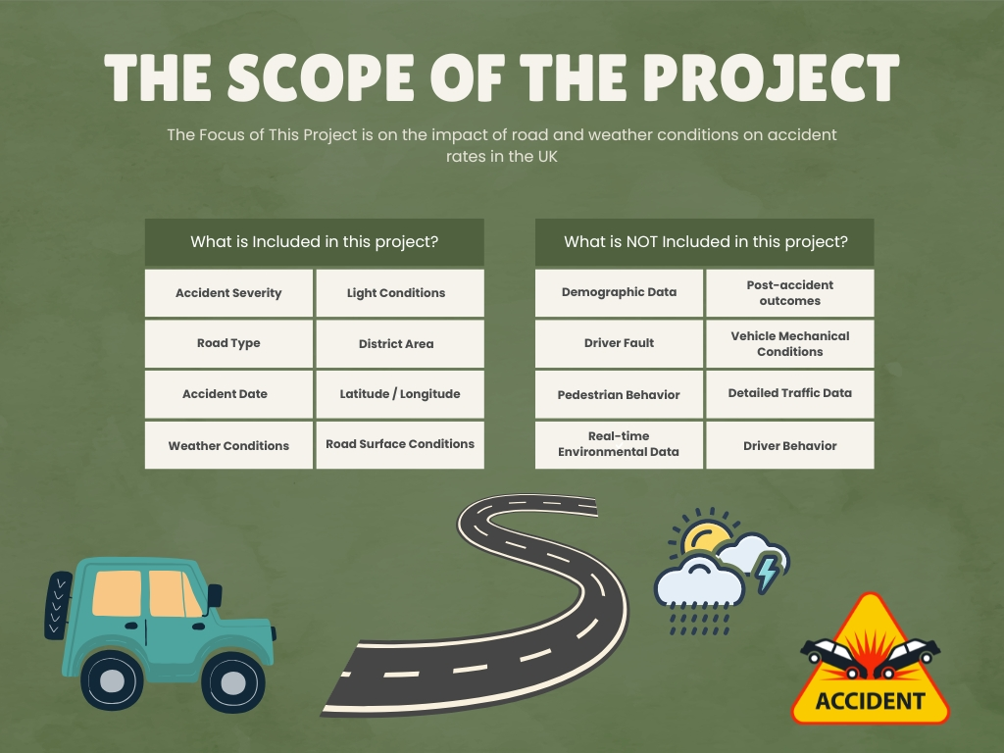

Figure 1- Project Scope

# Problem Statement

In the United Kingdom, traffic accidents remain a major safety and public health concern. Accidents still have a significant financial and human cost, even with improvements in intelligent traffic systems, urban infrastructure, and driver awareness programs. In 2019, there were 153,158 recorded casualties, including 1,752 fatalities and 25,945 serious injuries, according to the UK Department for Transport (2020). These numbers highlight the critical need for data-driven, proactive safety measures that can stop incidents before they happen rather than only reacting to them after they do.

Current traffic safety measures are more often reactive than proactive, which is the main issue this initiative attempts to address. It is frequently only after multiple instances that high-risk areas, times, and environmental circumstances are discovered, leading to avoidable injuries and fatalities. Many of these accidents are likely to continue in the absence of focused interventions and predictive analysis.

This research intends to identify the primary risk variables influencing accident severity in the UK by methodically examining comprehensive accident data. Stakeholders like local councils, transportation authorities, and emergency services will be able to create and carry out policies that enhance urban safety and lower casualties thanks to these insights.

The project's ability to significantly improve road safety throughout the United Kingdom serves as its justification. Authorities can take action before accidents happen rather than after the fact by looking at accident data to identify the most dangerous situations, places, and times. Knowing the underlying risk variables, such as particular road layouts, environmental conditions, or vehicle kinds, might help identify significant trends that conventional monitoring frequently misses. By ensuring that road designs, enforcement tactics, and safety campaigns are supported by verifiable data, these insights will directly support public safety programs and dictate urban planning decisions.

There are a lot of possible advantages to doing this analysis. The results can serve as the foundation for better policy creation, where rules and safety precautions are adapted to local conditions. To make roads safer for all users, local governments and transportation authorities can utilize the results to prioritize infrastructure improvements in regions that are prone to accidents. Additionally, the project's results help raise driver awareness by addressing the most frequent and hazardous accident causes through focused communication initiatives. When combined, these enhancements can contribute to safer metropolitan areas, fewer fatalities, and a more proactive road safety culture.

# Research Questions

The analysis is guided by the research questions, which also guarantee that the project remains in line with the problem statement. This project will respond to the following questions based on the accident dataset and project objectives:

1. Does road and weather factors have any impact on the accident rates in the UK?

* Focuses on how road surface, lighting conditions, and weather affect minor, serious, and fatal crashes.

1. Is there any correlation between weather and road conditions which affect the number of accidents in the UK?

* Investigate the correlation between weather and road surface conditions.
* Study the correlation between road type and lighting conditions to determine the ultimate cause(s) of these accidents in the UK.

# Key Stakeholder Analysis

Table 1- Key Stakeholders

|  |  |  |  |  |  |  |  |
| --- | --- | --- | --- | --- | --- | --- | --- |
| Stakeholder Name | Contact Person (phone, email, address) | Impact | Influence | What is important to stakeholders | How could the stakeholder contribute to the project | How could the stakeholder block the project | Strategy to engage stakeholder |
| UK Department for Transport  (DFT) | Safety police officer -  Safetydepart@dft.gov.uk | High (offers funding priorities and traffic safety laws.) | High (strong control over trials and traffic laws) | Lowering casualties, enforcing policies, and improving road safety | Describe accident statistics, allow trials, and provide funding for the project. | Adjust funding priorities, postpone trial approvals, and restrict access to accident data. | Organize frequent progress meetings, provide insightful proposals, and make sure project objectives line up with governmental safety plans. |
| National Health Service (Emergency and health services) | Health officer - health@nhs.gov.uk | Medium (oversees the emergency care and recovery for accidents) | Medium (has little policy control but offers essential health data.) | Reducing injuries, speeding up emergency response, and ensuring hospitals can handle it. | To identify trends, collect and analyze injury and casualty data. | Restrict access to health information and divert focus from projects related to accidents. | Partner with healthcare providers to enhance safety and highlight the importance of prevention. |
| Road User (Drivers) | UK Driver Associate – info@ukdriver.org | High (Behavior directly influence accidents rates) | Medium (may influence public opinion but not governmental decisions) | Make sure there are fair laws, road safety, and minimal discomfort for drivers. | Participate in research surveys, offer helpful feedback to fellow drivers, and drive sensibly. | Raise objections to new rules, oppose their strict implementation, and place less emphasis on safety initiatives. | Conduct awareness campaigns, offer incentives for safe driving, and inform drivers the positive aspects of the project. |
| Insurance companies & Loss Adjusters | Claims Manager insuranc@risk.uk | Medium (contains important accident analysis claims data) | Low (little direct control over transportation policy) | Reduce the expense of accident claims, properly evaluate risks, and satisfy customers. | Exchange claims data to identify trends in accidents, encourage safety initiatives, and provide incentives for safe driving. | Limit access to claims information and participate less in safety initiatives | Participate in industry conversations, show how fewer claims add value, and encourage collaborative safety efforts. |
| Media | Channel 9 | Low  (carry out comprehensive, real-time reporting) | Medium  (influence  drivers on conditions ahead and provide alternate routes) | Better informed about road networks, road safety and weather condition alerts, traffic diversions | Reporting reliable information to the audience, informing  work-arounds and safety protocols | Misinformation, stirring up trade union propaganda, misrepresentation | Law enforcement and local authorities media briefings |

# 

# Project Deliverables

The deliverables of this project are as follows:

* Visual analytics dashboard.
* Report with data insights and recommendations.
* Presentation.

# Data Description

In general, the dataset is of acceptable quality for exploratory data analysis in Tableau, with adequate completeness, relevant variables, and geographical data for mapping. With these features, a variety of visualisations can be created, patterns can be identified, and relationships between road, weather conditions, and accident rates can be investigated. Nevertheless, visuals should be interpreted and explained with awareness of potential inconsistencies in categorical fields (e.g. spellings, formatting, or category naming, which could result in misclassification) and missing data since the dataset was analysed without cleaning. In Figure 2, the strengths and limitations of this dataset are discussed in detail.

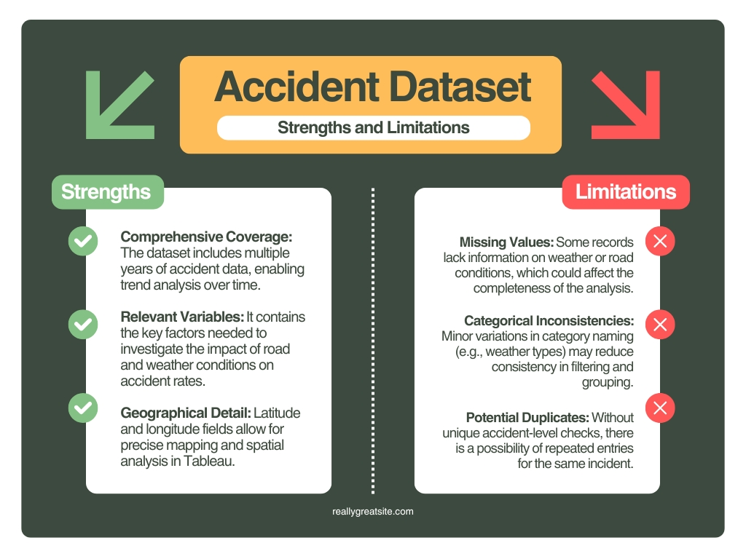

Figure 2- The Strengths & Limitations of the Dataset

# Reporting Visuals

In this section, visualisations generated using Tableau will be presented, and the key insights derived from the analysis will be explained to assess the impact of road and weather conditions on accident rates.

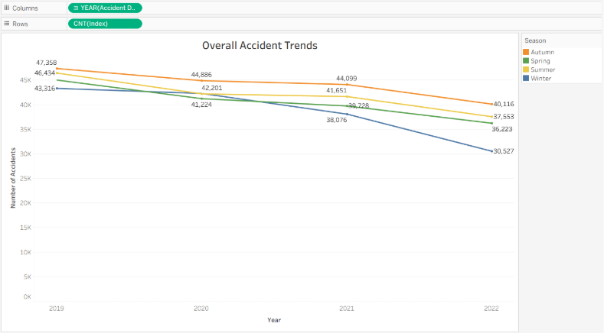

Figure 3- Overall Accident Trends

According to Figure 3, from 2019 to 2022, the accidents reduced across all seasons. Autumn continuously had the highest counts, followed by Summer and Spring, while Winter logged the lowest. The steepest decline happened in Winter from 2021 to 2022.

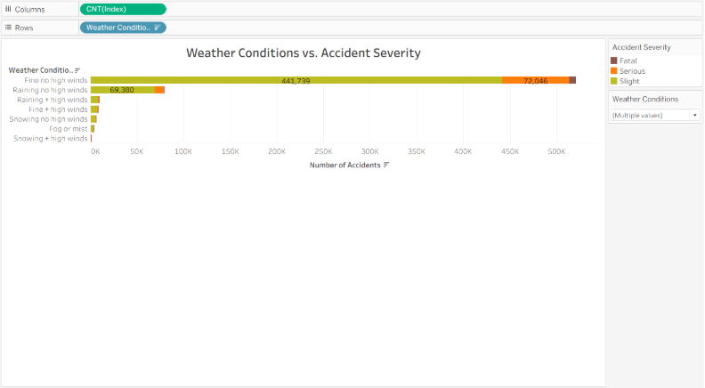

Figure 4- Weather Conditions vs. Accident Severity

Based on Figure 4, most accidents happened in fine weather without high winds and were mainly slight in severity, while poor weather conditions (e.g. rain, fog, and snow) had fewer incidents. Severe and fatal accidents were scarce across all other weather types.

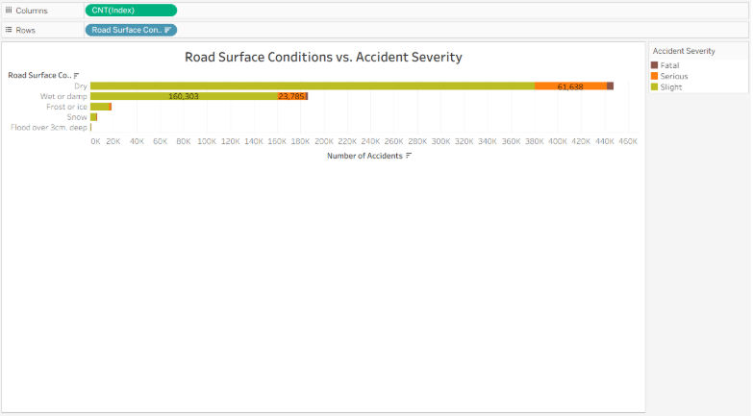

Figure 5- Road Surface vs. Accident Severity

As shown in Figure 5, the majority of accidents occurred on dry roads, followed by damp or wet surfaces, with both categories mainly composed of slight-severity incidents. Accidents on frost, ice, snow, or flood were rare in this dataset, and serious or fatal cases were relatively low across all conditions.

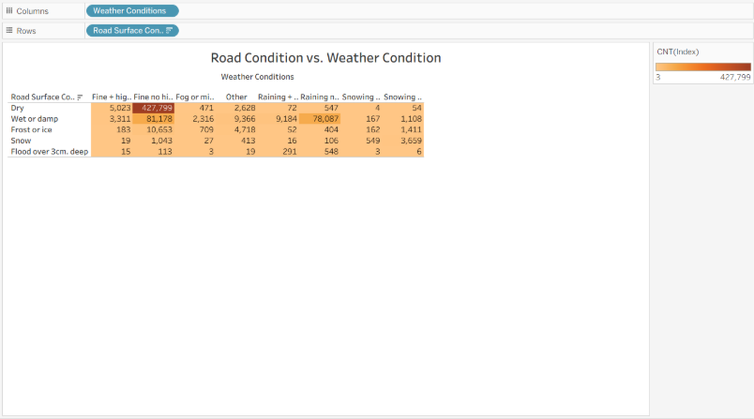

Figure 6- The Correlation Between Road & Weather Conditions

Figure 6 demonstrates that the largest proportion of the accidents took place on dry roads and in fine weather without high winds, followed by wet or damp surfaces under similar weather conditions. The third most common scenario was wet or damp road surfaces during rain with no high winds. Lastly, the number of accidents on frost, snow, ice, or flooded roads were fairly low.

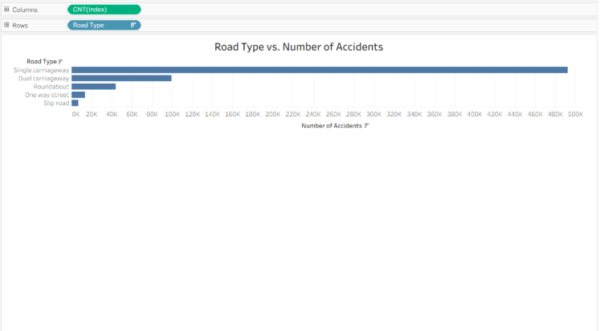

Figure 7- Road Type vs. Number of Accidents

As depicted in Figure 7, the vast majority of accident cases were observed on single carriageways, followed by dual carriageways and roundabouts. Incidents on one-way streets and slip roads were negligible in comparison.

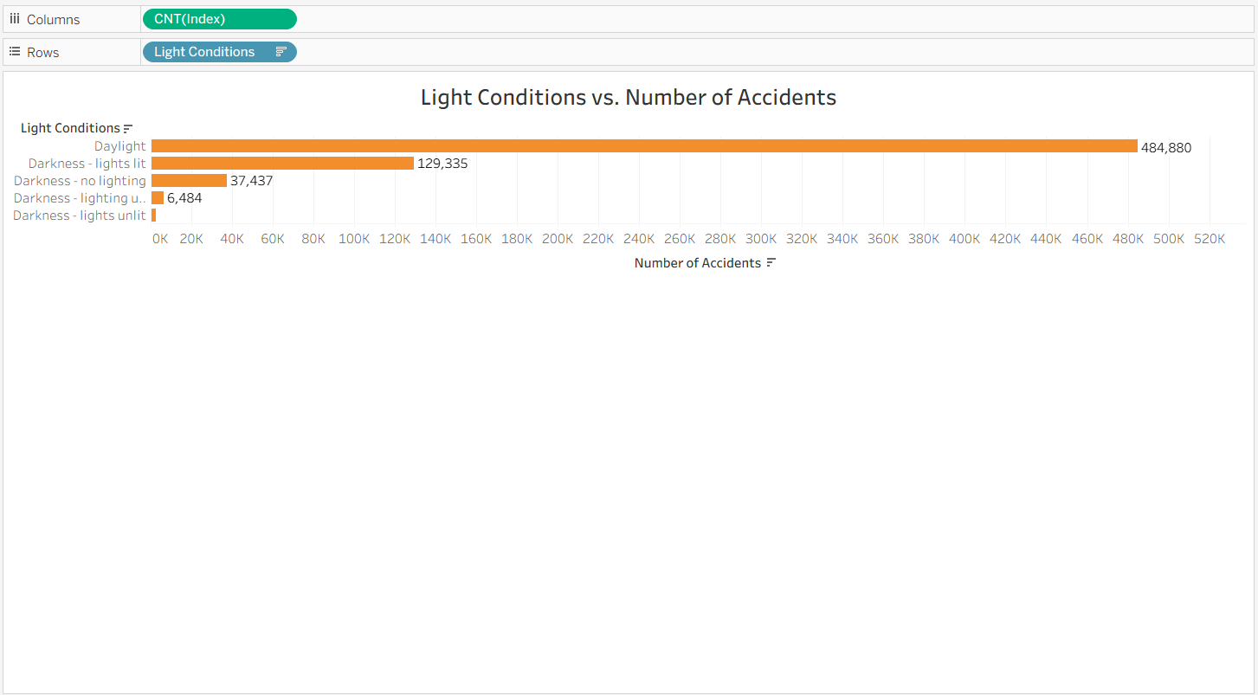

Figure 8- Light Conditions vs. Number of Accidents

Figure 8 illustrates that a large number of accidents took place in daylight, followed by darkness with street lights lit. Way fewer cases occurred in other lighting conditions, indicating a significant correlation between daylight and higher accident counts.

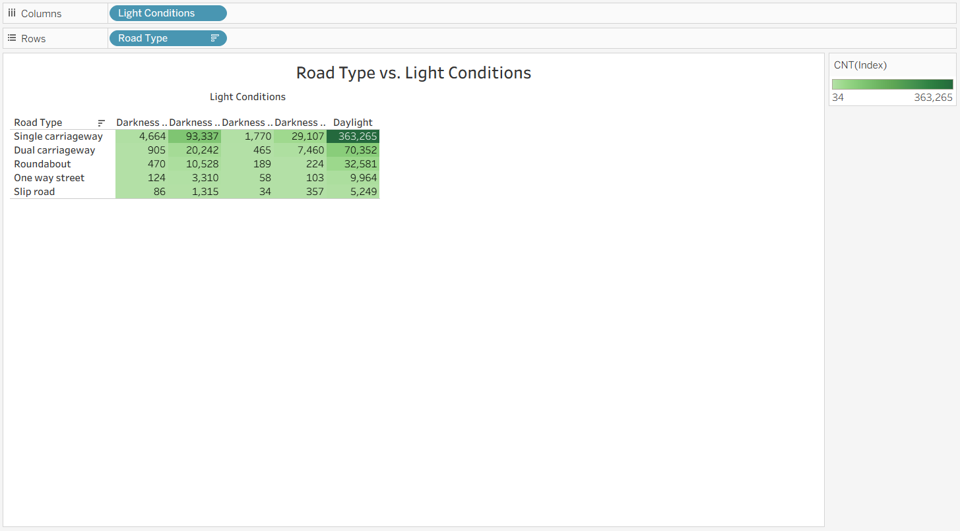

Figure 9- The Correlation Between Road Types & Light Conditions

As depicted in Figure 9, single carriageways are responsible for the vast majority of accidents across all light conditions, particularly in daylight and darkness with streetlights. Dual carriageways follow, with far fewer cases. Roundabouts, one-way streets, and slip roads have comparatively lower number of incidents in all lighting scenarios.

# Decision-making Process for Solution Selection

Investigation of supplied dataset shows that the large number of UK road crashes occur under fine, dry weather conditions on single carriageway roads. This conclusion is in line with a 2024 study involving 76% of UK road accidents which occur under clear skies indicating that bad weather is behind an insignificant number crashes (Honest John 2024).

An analysis of the data indicates that the number of accidents reported on single-carriageway roads is the highest. Independent research in road safety supports this very well since according to the research eight out of ten killed or seriously injured that were on the single-carriageway roads in England, Wales, and Scotland highlights the disproportionately high risks (IAM RoadSmart 2005). Moreover, official statistics confirm the undeniable fact that even motorway corridors, though they handle a great number of vehicles, consistently record significantly fewer casualties, which highlights the high level of risk associated with single-carriageways as opposed to other types of roads (Department for Transport 2022).

A tried and tested remedy to reduce the increased risk posed by single-carriageway roads is dualling, effectively turning them into dual carriageway with the central reservations. International Road Assessment Programme (iRAP) proves that duplication of roads results in the significant decrease of head-on collision, enhances turning safety, reduces the number and severity of crashes as well as physically isolating the direction of opposing streams of traffic (iRAP 2023). To buttress this argument, the A9 Dualling project of Transport Scotland, supplemented with average-speed cameras, has resulted in approximately 40 percent fewer fatal and serious casualties in renovated areas to prove dualling as an excellent and evidence-based safety measure (The A9 dualling project -Wikipedia 2025).

# Conclusion

The project’s analysis revels that most UK road accidents occur in fine, dry weather on single carriageways. Seasonal trends, lighting conditions and all road types all show clear patterns, while single carriageways pose the highest risks. Current safety measure are largely reactive and not in place for permanent solutions. The recommended solution is dual carriageway, supported by A9 Dualling Project case study. offering tangible, evidence-based strategy to significantly reduce fatalities so to avoid the issue of overtaking. By carrying out infrastructure improvements with necessary stakeholder collaboration, these insights help prioritize investments and ultimately enhancing road safety across the UK.

# References

Broughton, J 2008, 'Car driver casualty rates in Great Britain by type of car', Accident Analysis & Prevention, vol. 40, no. 4, pp. 1543–1552.

Clarke, DD, Ward, P & Truman, W 2002, In-depth accident causation study of young drivers, TRL Report 542, Transport Research Laboratory, Crowthorne.

Department for Transport 2024, Reported Road casualties Great Britain: annual report 2023, GOV.UK, viewed 3 August 2025, https://www.gov.uk.

Department for Transport (DfT) 2020, Reported Road Casualties Great Britain: 2019 Annual Report, UK Government, viewed 12 August 2025, https://www.gov.uk/government/statistics/reported-road-casualties-great-britain-annual-report-2019.

Department for Transport (2022) Reported Road Casualties Great Britain, annual report: 2022. Available at: https://www.gov.uk/government/statistics/reported-road-casualties-great-britain-annual-report-2022 (Accessed: 13 August 2025).

Elvik, R 2019, ‘The importance of confounding in observational before-and-after studies of road safety measures’, Accident Analysis & Prevention, vol. 127, pp. 8–16, doi:10.1016/j.aap.2019.02.018.

Honest John (2024) Majority of car crashes happen in good weather. Available at: https://www.honestjohn.co.uk/news/driving/2024-05/majority-of-car-crashes-happen-in-good-weather/ (Accessed: 13 August 2025).

International Road Assessment Programme (iRAP) (2023) Duplication – Road Safety Toolkit. Available at: https://toolkit.irap.org/safer-road-treatments/duplication (Accessed: 13 August 2025).

IAM RoadSmart (2005) Rural Roads: KSI Statistics. Available at: https://www.iamroadsmart.com/docs/default-source/research-reports/iam-rural-roads.pdf (Accessed: 13 August 2025).

National Highways 2021, Road Safety Data and Analysis, National Highways, UK, viewed 12 August 2025, https://nationalhighways.co.uk/our-work/road-safety.

Pöllänen, M. 2010, Wintertime road conditions and accident risks in passenger car traffic, presented at the 13th Winter Road Congress Meeting, Quebec City, Canada.

Wikipedia (2025) A9 dualling project. Available at: https://en.wikipedia.org/wiki/A9_dualling_project (Accessed: 13 August 2025).

World Health Organization (WHO) 2018, Global Status Report on Road Safety 2018, World Health Organization, Geneva, viewed 12 August 2025, https://www.who.int/publications/i/item/9789241565684.

# Contribution Log

|  |  |  |  |  |  |  |
| --- | --- | --- | --- | --- | --- | --- |
| **BUSM7105 Applied Project: Contribution Log Template** | | | | | | |
|  |  | **Student 1 – Mia Dehghan** | **Student 2 – Zarrar Khan** | **Student 3 – Anu Poudel** | **Student 4 – Andrew Parimalasingham** | **Student 5 – Israt Jahan Joty** |
| **Wed**  **Jul 30** | Meeting 1: Task allocation | Scope of the project  Project Deliverables  Data Description  Reporting visuals  DM Process | Data Description,  Reporting Visuals,  Decision-making Process | Introduction  Key Stakeholders Analysis | Executive Summary, Key Stakeholder Analysis, Conclusion | Problem Statement, Research Questions |
| Signed by the student | Maedeh Dehghan (Mia) | Zarrar Khan | Anupama Poudel  (Anu) | Andrew Mark Parimalasingham | Israt Jahan Joty |
| **Mon**  **Aus 4** | Meeting 2: Status | Progress:    Working on project scope section.    Going through dataset and identifying the essential analysis for this project | Progress:    Creating basic visuals from the dataset to see a pattern. | Progress:    -Researched about the road accident in UK  and started with the introduction | Progress:    Understanding the specificities of the project, such as the key findings and project aim (group brainstorm)    Research and mentally applying key stakeholder analysis based on findings | Progress:  Research and preparation completed for my sections.  Ready to start writing my allocated parts in the group project for the next phase. |
| Satisfactory/unsatisfactory (Tick or Cross by each group member) | |  |  |  |  |  | | --- | --- | --- | --- | --- | |  |  |  |  |  | | |  |  |  |  |  | | --- | --- | --- | --- | --- | |  |  |  |  |  | | |  |  |  |  |  | | --- | --- | --- | --- | --- | |  |  |  |  |  | | |  |  |  |  |  | | --- | --- | --- | --- | --- | |  |  |  |  |  | | |  |  |  |  |  | | --- | --- | --- | --- | --- | |  |  |  |  |  | |
| **Mon**  **11 Aug** | Meeting 3: Status | Progress:  Drafted Project Scope and Data description section.  Analysed data and created visuals. | Progress:  Did research on the decision making section. | Progress:  The Introduction is drafted, and working on the key stakeholder analysis | Progress: | Progress:    Write problem statement and research question, now waiting for group member feedback, after everyone finished work on their parts i start to write project deliveries |
| Satisfactory/unsatisfactory (Tick or Cross by each group member) | |  |  |  |  |  | | --- | --- | --- | --- | --- | |  |  |  |  |  | | |  |  |  |  |  | | --- | --- | --- | --- | --- | |  |  |  |  |  | | |  |  |  |  |  | | --- | --- | --- | --- | --- | |  |  |  |  |  | | |  |  |  |  |  | | --- | --- | --- | --- | --- | |  |  |  |  |  | | |  |  |  |  |  | | --- | --- | --- | --- | --- | |  |  |  |  |  | |
| **Thu 14 Aug** | Meeting 4: Status | Progress:  Drafted project deliverables section  Finalised and beautified the report | Progress:  Drafted decision-making section | Progress:   I have completed my section and revised it for final submission | Progress:  Finalised the conclusion and executive summary | Progress:    Complete all my part and revised them all. |
| Satisfactory/unsatisfactory (Tick or Cross by each group member) | |  |  |  |  |  | | --- | --- | --- | --- | --- | |  |  |  |  |  | | |  |  |  |  |  | | --- | --- | --- | --- | --- | |  |  |  |  |  | | |  |  |  |  |  | | --- | --- | --- | --- | --- | |  |  |  |  |  | | |  |  |  |  |  | | --- | --- | --- | --- | --- | |  |  |  |  |  | | |  |  |  |  |  | | --- | --- | --- | --- | --- | |  |  |  |  |  | |